Moffat Bay Marina
Module 8 — Functional Test Results
Look Up Reservation
Project | Moffat Bay Marina
Course | CSD 460 — Capstone in Software Development
Description | Functional test results for the Marina Look Up Reservation page and backend lookup flow.
Developer | Aftabur Rahman / Green Team
Date Tested | 2026/09/10
Peer Tester | Alexander Baldree
Status | Draft — 4 of 4 Marina functional tests completed; peer verification pending
This document records four functional tests for the Marina Look Up Reservation and Contact Us functionality. The tests verify successful retrieval of an existing reservation, rejection of invalid reservation information, successful loading of the Contact Us page, and successful submission of the Contact Us form. Developer-level testing is complete; peer verification remains pending.
Test 1 — Successful Reservation Lookup
Test Objective: Verify that a valid reservation ID and matching customer email retrieve the correct reservation details.
Developer: Aftabur Rahman / Green Team
Date tested: 2026/09/10
Peer tester: Alexander Baldree 09/20/26
Step | Action | Expected Result | Developer | Peer Tester
1 | Open the Look Up Reservation page. | The lookup form loads with fields for Reservation ID and Email Address. | YES | 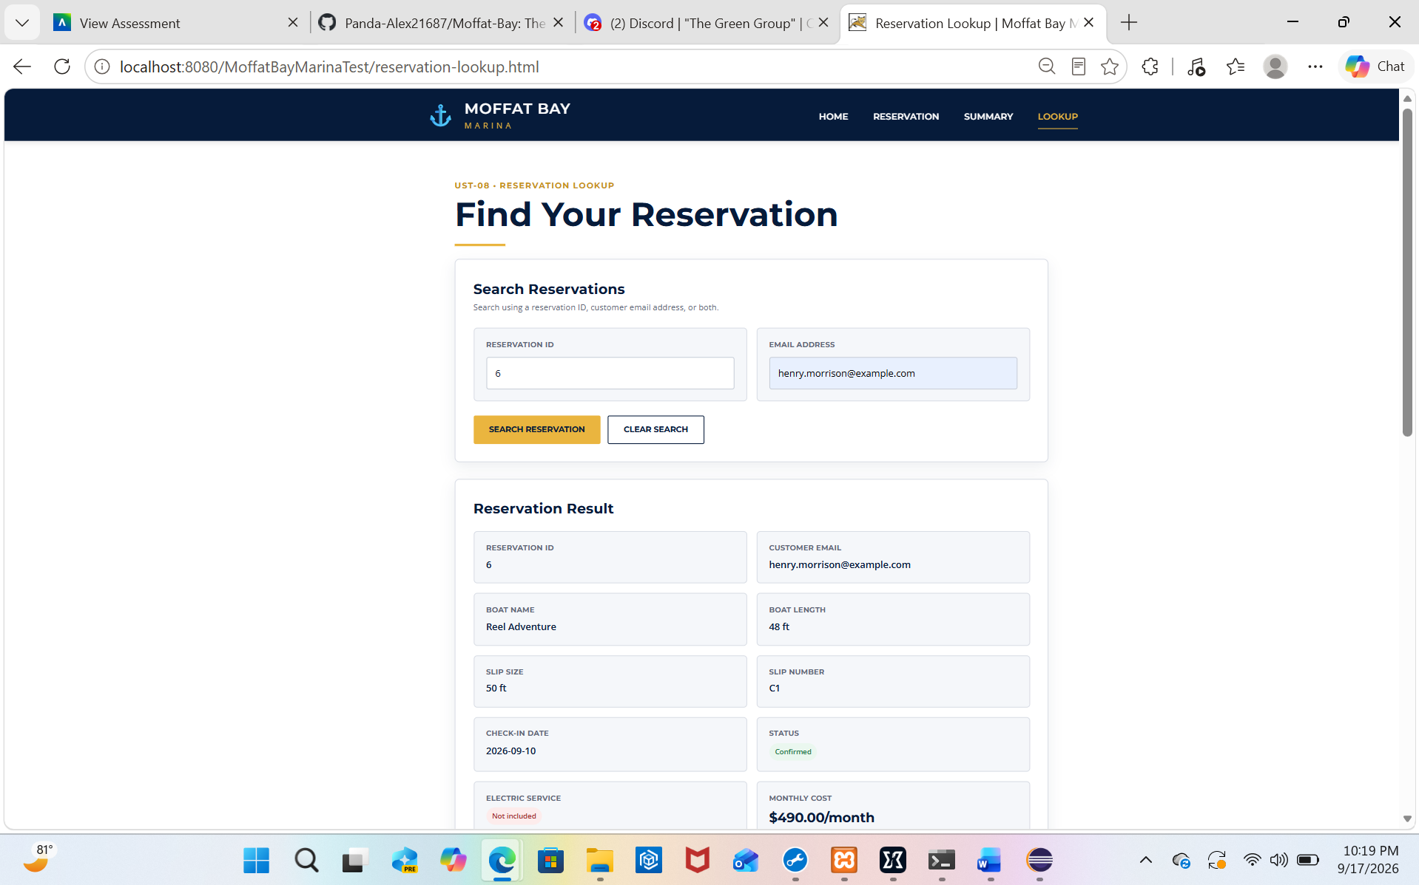
2 | Enter Reservation ID 6 and email henry.morrison@example.com. | The form accepts the reservation information. | YES | 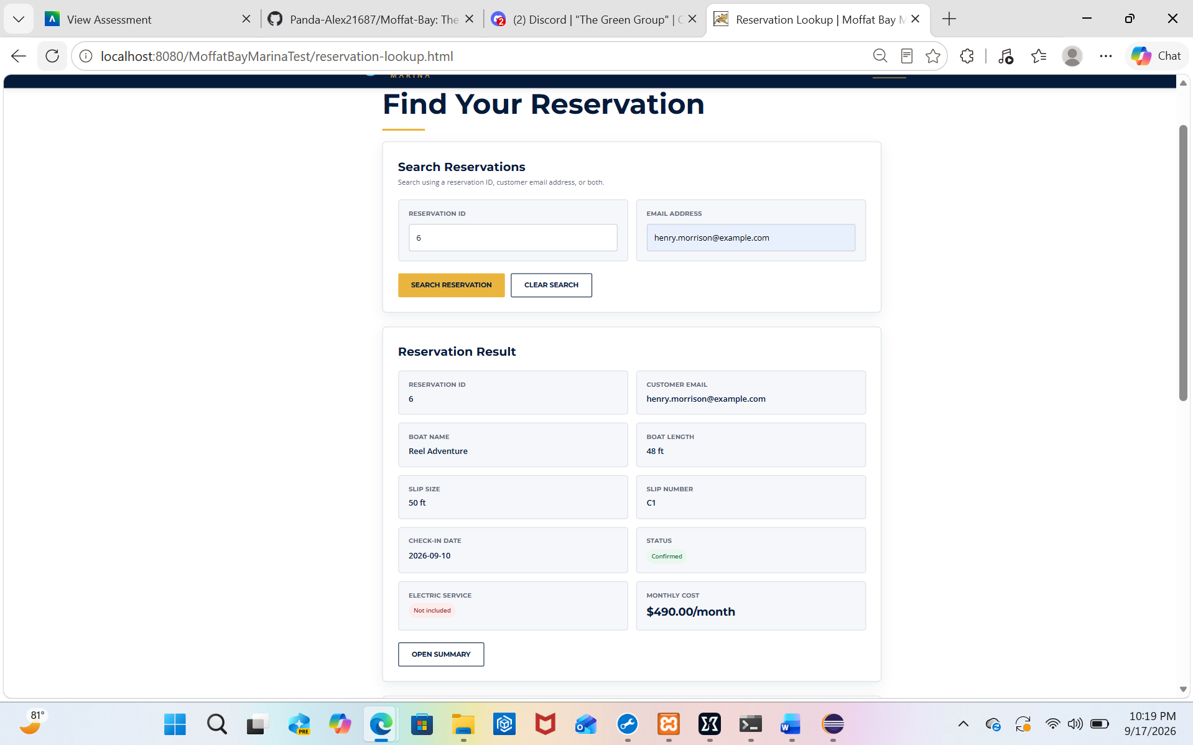
3 | Select Look Up Reservation. | The application processes the request and displays the reservation details page. | YES
4 | Review the returned reservation information. | Reservation ID 6, Henry Morrison, email, Slip C1, check-in date 2026-09-10, Monthly term, $490 monthly cost, and CONFIRMED status are displayed. | YES | 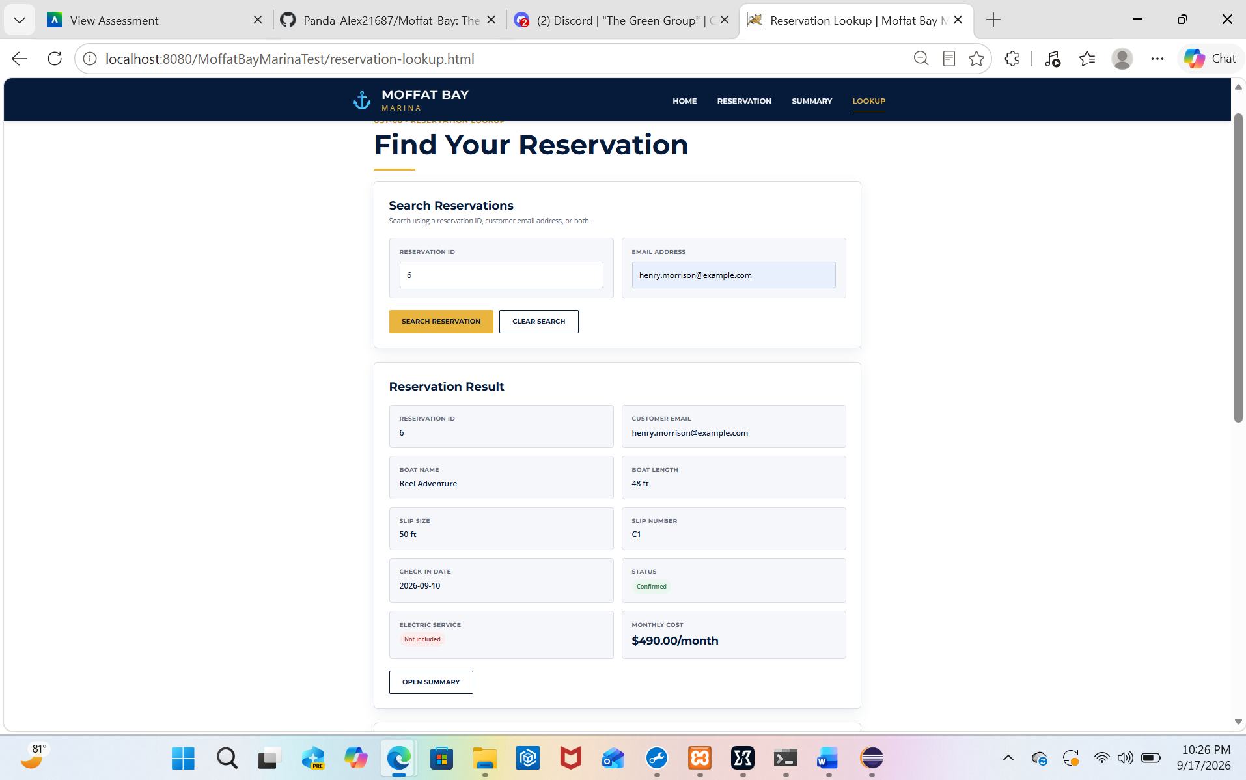
Comments: The lookup successfully retrieved the existing reservation using the correct reservation ID and matching email address. The returned information matched the reservation record, demonstrating that the lookup page and backend retrieval flow are functioning correctly.
Screenshot 1: Successful lookup displaying Reservation ID 6 and its reservation details.

Test 2 — Invalid Reservation Lookup
Test Objective: Verify that the system does not return reservation information when an invalid reservation ID is submitted with an email address.
Developer: Aftabur Rahman / Green Team
Date tested: 2026/09/10
Peer tester: Alexander Baldree 09/20/26
Step | Action | Expected Result | Developer | Peer Tester
1 | Open the Look Up Reservation page. | The lookup form loads successfully. | YES
2 | Enter Reservation ID 99999 and email henry.morrison@example.com. | The form accepts the entered information. | YES | 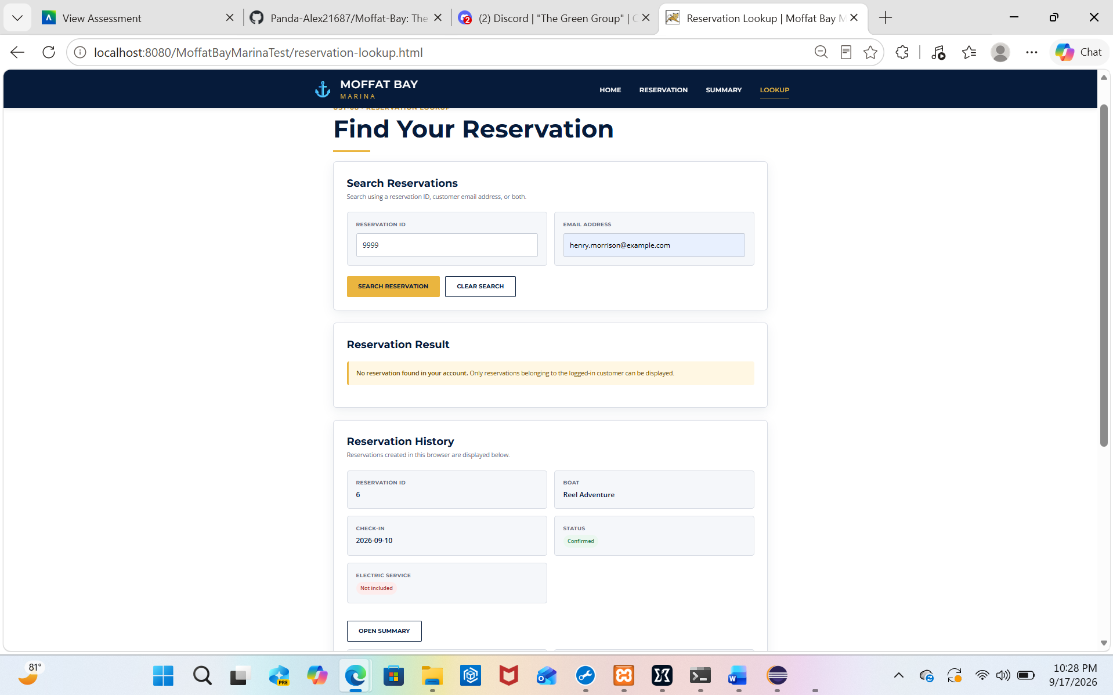
3 | Select Look Up Reservation. | The application processes the request without exposing reservation information for the invalid ID. | YES
4 | Review the result. | The page displays: 'No reservation was found with the information provided.' | YES
Comments: The system correctly rejected the nonexistent reservation ID and did not display reservation information. The clear 'No reservation was found' message provides useful feedback to the user and confirms that invalid lookup requests are handled appropriately.
Screenshot 2: Invalid lookup displaying the 'No reservation was found' message.

Testing Summary
Two Marina functional tests for the Look Up Reservation feature have been completed and passed at the developer-test level. Peer tester verification and the remaining two Module 8 Marina functional tests are still pending.

Test 3 — Contact Us Page Load
Test Objective: Verify that the public Contact Us page loads successfully and displays the expected contact information and contact form.
Developer: Aftabur Rahman / Green Team
Date tested: 2026/09/18
Peer tester: Alexander Baldree
Peer verification: 09/20/26
Step | Action | Expected Result | Developer | Peer Tester
1 | Open http://localhost:8080/contact.html in a browser. | The Contact Us page loads successfully without a server error. | YES | YES  Integrated with about us page as per clients request  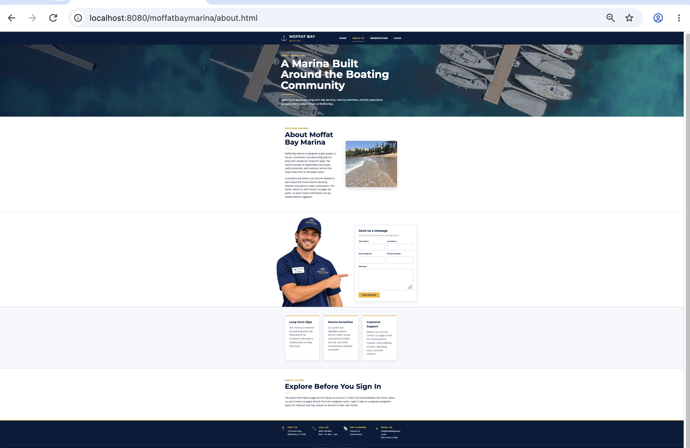
2 | Review the page heading and contact information. | The page displays the Moffat Bay Marina contact information, including address, phone, VHF channel, and email. | YES | YES  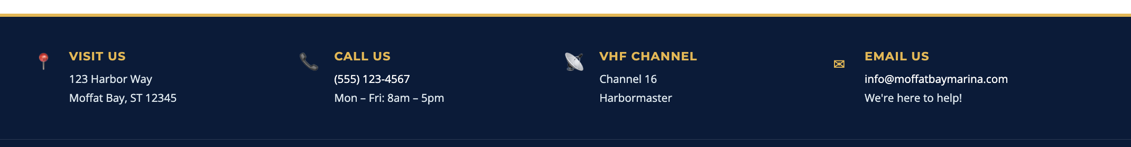
3 | Review the contact form. | The form displays First Name, Last Name, Email Address, Phone Number, Message, and the SEND MESSAGE button. | YES | YES  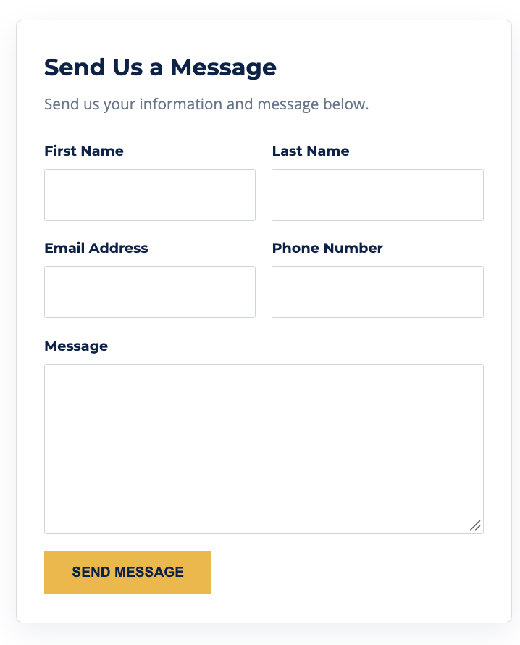
4 | Verify the public-page section. | The page states that no login is required to access the Contact Us page. | YES | YES  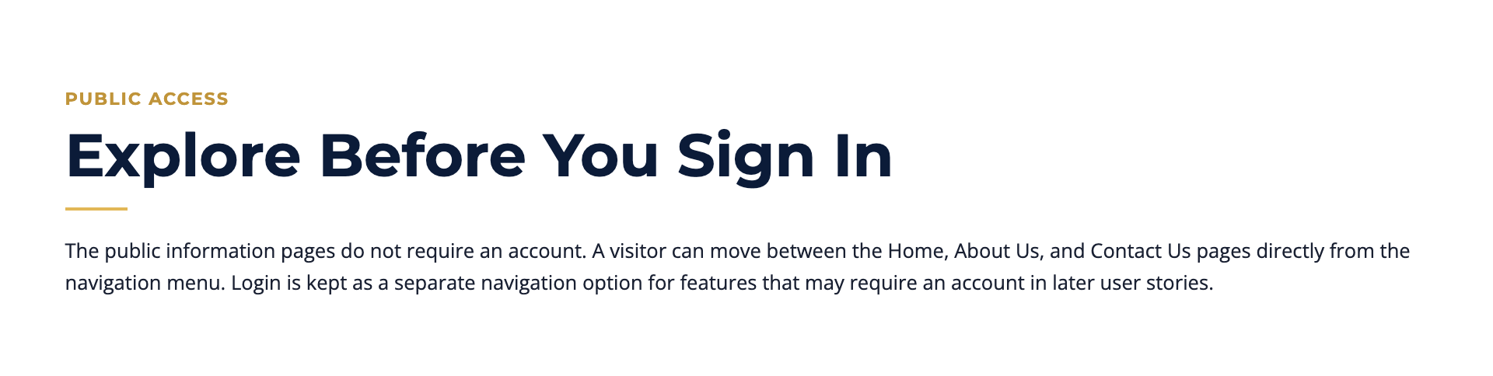
Comments: The Contact Us page loaded successfully and displayed the required public contact information and contact form. The page is accessible without authentication, providing the expected public-facing contact functionality.

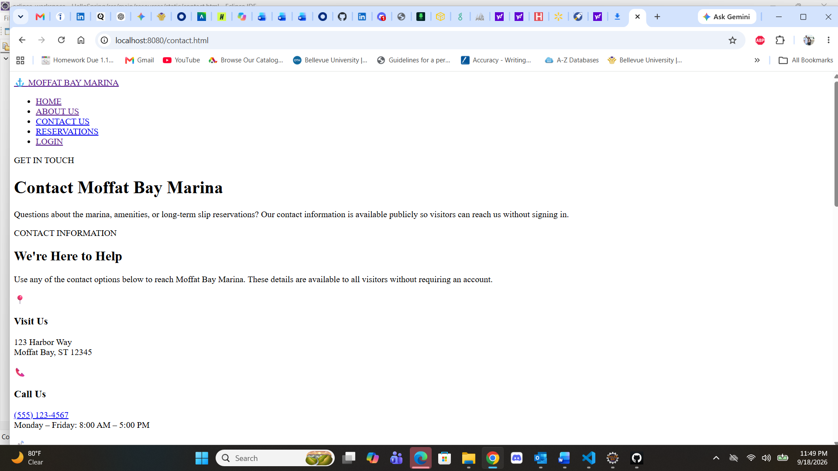
Screenshot 3: Contact Us page loaded successfully with contact information and the public contact form.

Test 4 — Successful Contact Form Submission
Test Objective: Verify that a completed Contact Us form is accepted by the Spring Boot backend and redirects to the confirmation page.
Developer: Aftabur Rahman / Green Team
Date tested: 2026/09/18
Peer tester: Alexander Baldree
Peer verification: 09/20/26
Step | Action | Expected Result | Developer | Peer Tester
1 | Enter valid first name, last name, email, phone number, and message information. | The form accepts the completed contact information. | YES | Yes  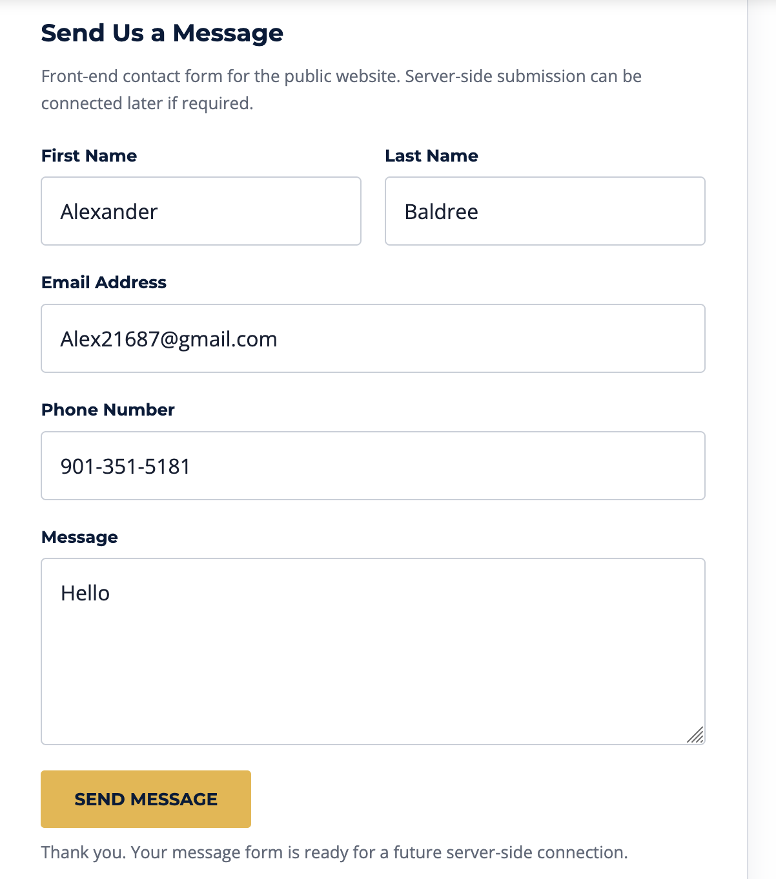
2 | Select SEND MESSAGE. | The application submits the form to the /contact backend endpoint. | YES | YES  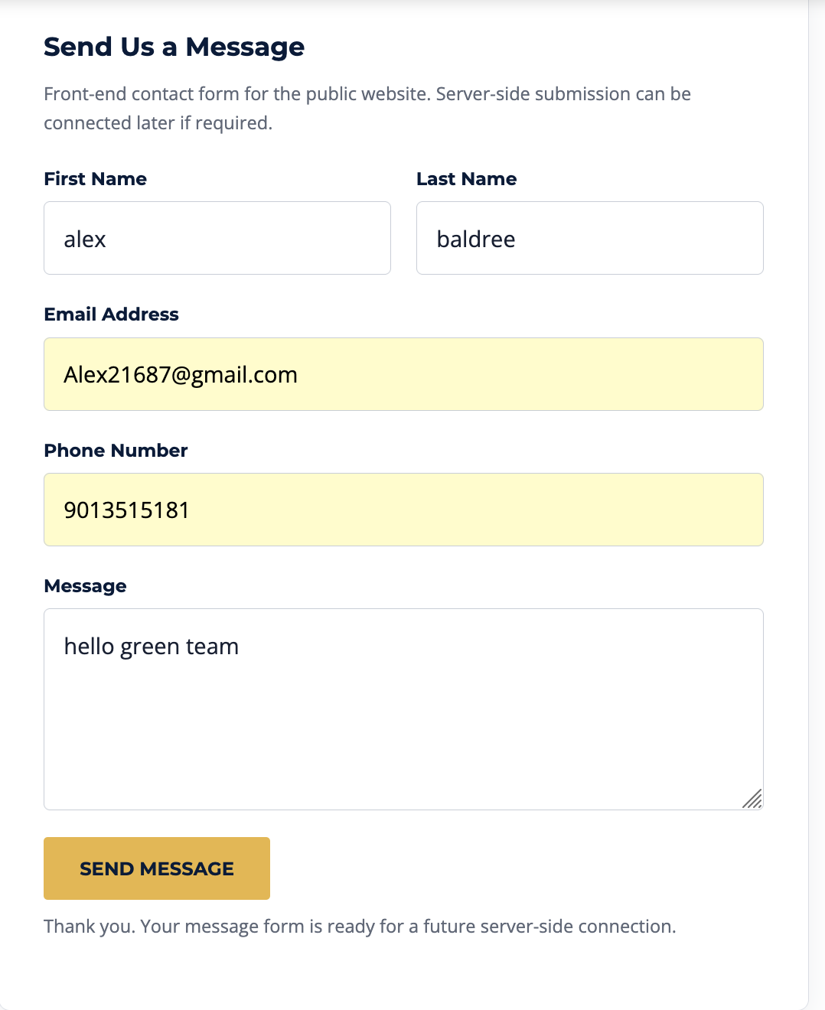
3 | Observe the returned page. | The application redirects to contact-confirmation.html. | YES | YES  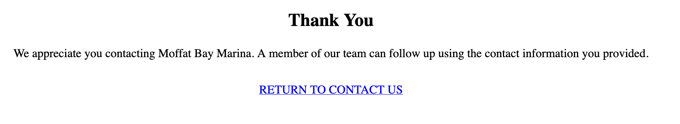
4 | Review the confirmation message. | The confirmation page displays 'Thank You for Contacting Us' and confirms that the message was received. | YES | YES  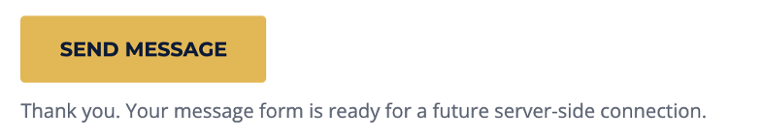
Comments: The completed Contact Us form was successfully submitted to the Spring Boot backend and redirected to the confirmation page. The confirmation message provides clear feedback that the submission was received, demonstrating that the frontend form and backend controller are connected correctly.

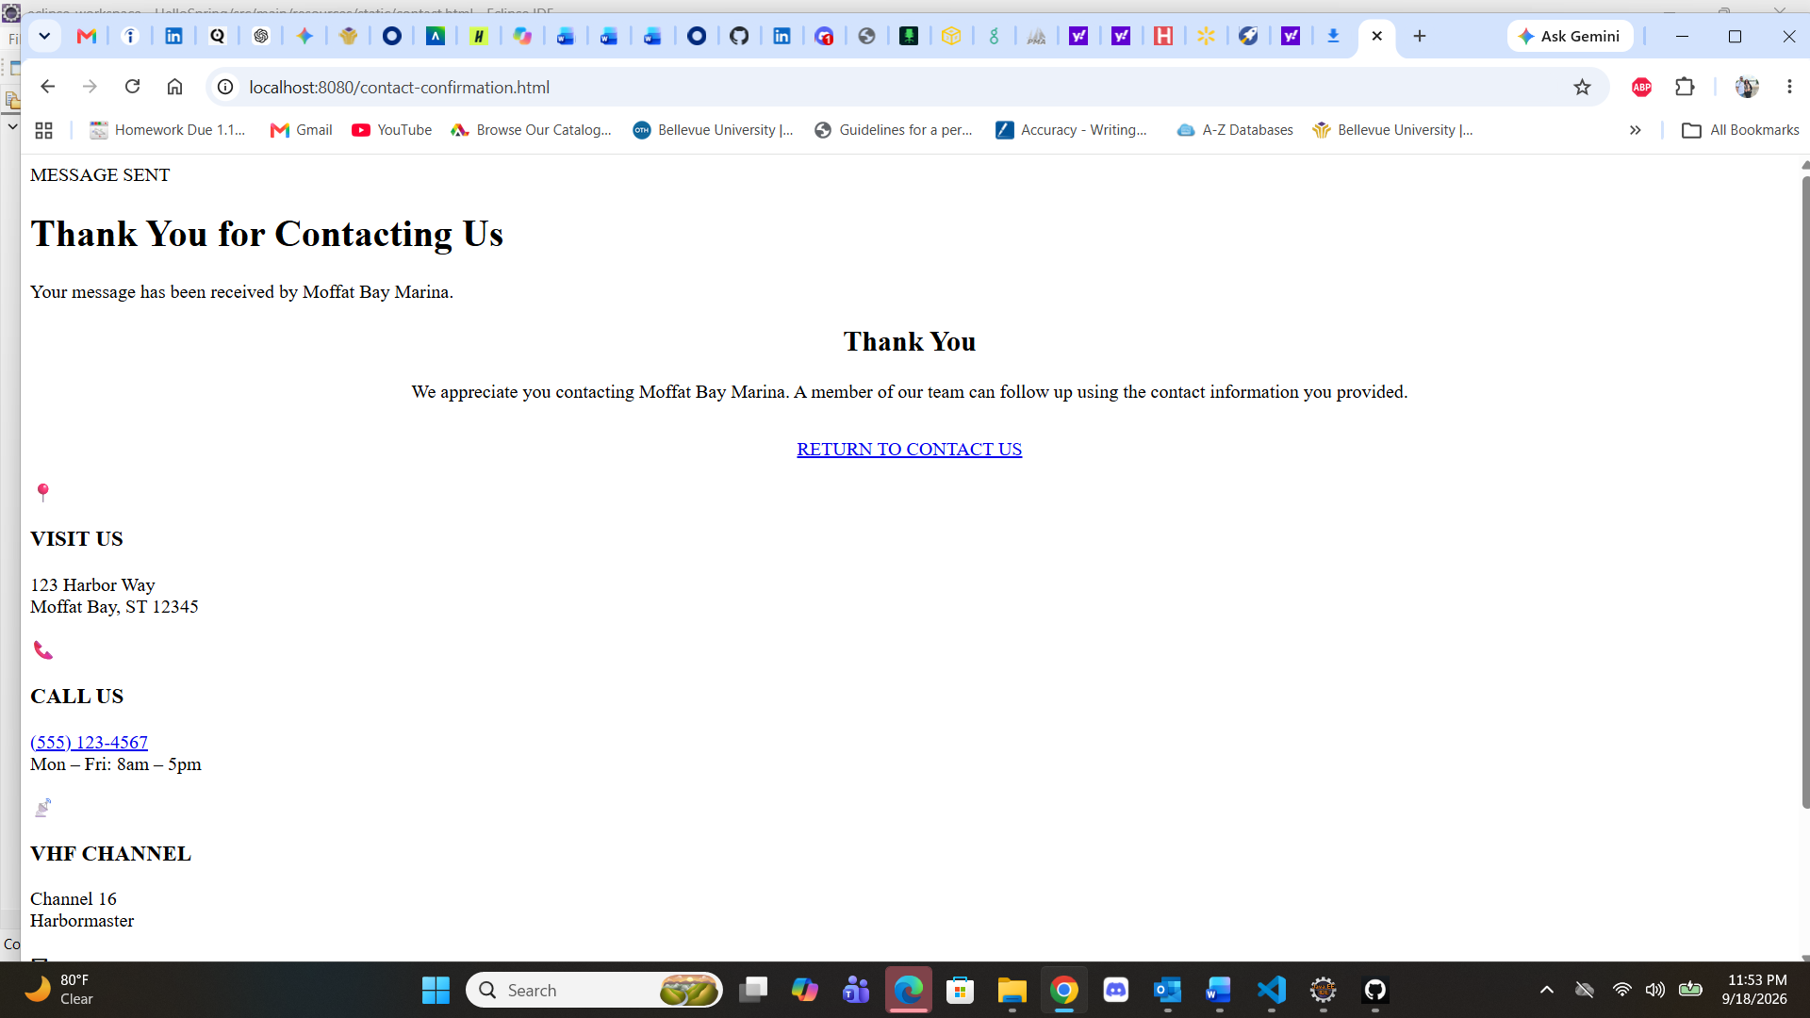
Screenshot 4: Contact form submission successfully redirected to the Contact Us confirmation page.

Testing Summary
All four required Module 8 Marina functional tests have been completed successfully at the developer-test level. The Look Up Reservation tests verify successful retrieval and appropriate handling of invalid reservation information. The Contact Us tests verify public page loading and successful form submission to the Spring Boot backend. Alexander Baldree is identified as the peer tester; peer verification remains pending.
Test | Result | Peer Verification
Test 1 — Successful Reservation Lookup | PASS | PASS
Test 2 — Invalid Reservation Lookup | PASS | Passed as failed/ invalid true
Test 3 — Contact Us Page Load | PASS | PASS
Test 4 — Successful Contact Form Submission | PASS | PASS

